Final Report



Technology Stack: Data Analytics with Tableau
Project Title: Indian agriculture crop production analysis
Team ID:LTVIP2024PMID1313
Team Members:
- Y. Bhavana Lakshmi
- K. Abhinaya
- P. Anjaneyulu
- S. Niyander
College : Kallam Haranadhareddy Institute Of Technology

INDEX

SNO | TITLE | PAGE NO
1 | Introduction | 3
2 | Abstract | 5
3 | Empathy Map Canvas | 6
4 | Brainstorming and Idea Prioritization | 8
5 | Stage – 1 | 10
6 | Report on Practice Website | 12
7 | Report on Main Website | 14
8 | Stage – 2 | 16
9 | Stage – 3 | 18
10 | Output Screens | 20
11 | Conclusion | 22
12 | Future Scope | 23
13 | References | 26

INTRODUCTION

India's agricultural sector serves as the cornerstone of the nation's economy, providing livelihoods for millions and ensuring food security for its vast population. With diverse climates, varied soil types, and a rich farming heritage, India cultivates a wide array of crops, ranging from staples like rice and wheat to cash crops such as cotton and spices. However, amidst rapid urbanization and evolving socio-economic dynamics, the sector encounters both opportunities and challenges, necessitating a deeper understanding of crop production patterns and dynamics.

Agriculture's significance extends beyond economic contributions; it is a vital source of employment, particularly in rural areas, and plays a pivotal role in nourishing the population. Despite its importance, the sector grapples with challenges like fragmented land holdings, water scarcity, climate variability, and technological constraints, impacting productivity and sustainability.

Recognizing the need for data-driven approaches, there is a growing emphasis on leveraging advanced analytics tools to address agricultural complexities. In this study, we employ Tableau, a powerful data visualization tool, to analyze Indian agriculture crop production data and uncover insights into production patterns and dynamics.

Tableau's intuitive interface and interactive dashboards facilitate the exploration of complex datasets, empowering stakeholders to make informed decisions. By integrating Tableau's capabilities, we aim to create a visually compelling narrative of crop production, enabling stakeholders to gain deeper insights and drive positive change in the sector.

This study adopts a multi-faceted approach, analyzing various variables like crop yields, production volumes, climatic factors, and socio-economic indicators across different regions and years. Drawing on comprehensive datasets, sourced from governmental and research institutions, we seek to inform evidence-based decision-making, optimize resource allocation, and enhance agricultural productivity and sustainability.

In conclusion, the integration of Tableau into the analysis of Indian agriculture crop production data signifies a significant step towards leveraging data-driven approaches to address sectoral challenges. By providing actionable insights and fostering informed decision-making, this study endeavors to contribute to the advancement of the Indian agricultural sector and the well-being of its stakeholders. Through collaboration and innovation, we strive to drive sustainable agricultural development in India.

ABSTRACT

This study delves into the analysis of Indian agriculture crop production using data analytics with Tableau. India's agricultural landscape is diverse, encompassing various crops cultivated across different regions and seasons. Understanding the intricate patterns and dynamics of crop production is crucial for enhancing productivity and sustainability in the sector. Leveraging data analytics techniques and Tableau's visualization capabilities, this research explores trends, disparities, and factors influencing crop yields.

Through comprehensive data exploration, district-level dynamics, and seasonal variations are examined to uncover valuable insights. The study identifies key drivers of crop production variability and provides actionable recommendations for policymakers, researchers, and stakeholders. By optimizing agricultural practices based on evidence-based insights, the aim is to enhance productivity and promote sustainability in Indian agriculture.

This abstract summarizes the significance of analyzing Indian agriculture crop production data using data analytics with Tableau, highlighting the potential for informed decision-making and positive impact on the sector's development.

EMPATHY MAP CANVAS

Creating an empathy map canvas for Indian agriculture crop production analysis in data analytics with Tableau involves understanding the needs, thoughts, feelings, and experiences of various stakeholders involved in the agricultural sector.
Empathy Map Canvas: Indian Agriculture Crop Production Analysis :
- What They Say:
- Farmers: "We struggle to predict crop yields and face uncertainties in
production."
- Policymakers: "We need data-driven insights to formulate effective
agricultural policies."
- Researchers: "Understanding regional variations in crop production is
crucial for our studies."
- Stakeholders: "We seek actionable insights to improve agricultural
practices and sustainability."
- What They Do:
- Farmers: Collect data on crop yields, weather patterns, and soil quality.
- Policymakers: Review reports and studies on agricultural productivity and
sustainability.
- Researchers: Analyze datasets to identify trends and correlations in crop
production.
- Stakeholders: Attend conferences and workshops on agricultural innovation and technology.
- What They Think and Feel:
- Farmers: Concerned about fluctuating market prices and unpredictable weather conditions.
- Policymakers: Feel the pressure to address food security and rural livelihood challenges.
- Researchers: Curious about uncovering hidden patterns and insights in agricultural data.
- Stakeholders: Hopeful for solutions that can drive positive change in the agricultural sector.
- What They See:
- Farmers: Variations in crop yields across different regions and seasons.
- Policymakers: Reports highlighting the importance of data-driven decision-making in agriculture.
- Researchers: Datasets containing vast amounts of agricultural data waiting to be analyzed.
- Stakeholders: Innovations in technology and data analytics transforming agricultural practices.
- What They Hear:
- Farmers: Advice from agricultural experts on improving crop management techniques.
- Policymakers: Feedback from farmers and stakeholders on the effectiveness of agricultural policies.
- Researchers: Insights and findings shared at conferences and research seminars.
- Stakeholders: Success stories of farms implementing data-driven solutions for better yields.
Understanding the perspectives and needs of stakeholders in the agricultural sector is crucial for developing effective solutions and insights through data analytics with Tableau. By empathizing with their challenges, aspirations, and experiences, we can tailor our analysis and visualization efforts to provide valuable insights and drive positive change in Indian agriculture.

BRAINSTORMING AND IDEA PRIORITIZATION

Brainstorming and idea prioritization for Indian agriculture crop production analysis in data analytics with Tableau involves generating and evaluating potential approaches, techniques, and insights that can be derived from the data.

Brainstorming :

Define the primary goals of the analysis, such as identifying trends, understanding factors influencing crop production, and providing actionable insights for stakeholders.Analyzing historical crop production data to identify trends over time.

Examining regional variations in crop yields and exploring factors contributing to disparities.

Conducting predictive modeling to forecast future crop production based on historical data and climate projections.

Integrating satellite imagery and remote sensing data to assess crop health and monitor agricultural practices.

Creating interactive dashboards in Tableau to visualize spatial and temporal patterns in crop production.

Encourage participants to think creatively and explore a wide range of ideas, regardless of feasibility or practicality at this stage.

Idea Prioritization :

Establish criteria for evaluating and prioritizing ideas, such as impact on stakeholders, feasibility, data availability, and alignment with project objectives.Have participants vote or rate each idea based on the defined criteria. This can be done anonymously to encourage honest feedback.Facilitate a discussion to further refine and prioritize the top-ranked ideas.

Which ideas align most closely with the project objectives and stakeholder needs?

Are there any ideas that could potentially have a high impact but require additional resources or expertise?

Are there any low-hanging fruit or quick wins that can be implemented with minimal effort?

Encourage consensus among participants by discussing trade-offs and considering the collective input of the group. Based on the discussion and feedback, finalize the prioritized list of ideas. Consider creating a roadmap or action plan outlining the implementation steps for each prioritized idea.

STAGE-1

Title of the Project:- Indian agriculture crop production analysis in data analytics with Tableau

Overview:

Stage 1 of the project involves laying the groundwork for Indian agriculture crop production analysis using data analytics with Tableau. This stage focuses on defining the project scope, collecting relevant data sources, and setting objectives and milestones.

Project Scope Definition:

Define the scope of the analysis, including the geographical coverage, crop types, and time frame.Identify key stakeholders and their requirements for the analysis.

Data Collection and Preparation :

Gather relevant datasets from governmental and agricultural organizations, including crop yields, cultivation areas, weather patterns, and soil characteristics.Cleanse and preprocess the collected data to ensure consistency and reliability for analysis

Objective Setting :

Set clear objectives for the analysis, such as identifying trends, exploring factors influencing crop production, and providing actionable insights for stakeholders.Define metrics and key performance indicators (KPIs) to measure the success of the analysis.

Tools and Technologies :

Select appropriate tools and technologies for data analytics and visualization, with a focus on leveraging Tableau for its powerful visualization capabilities.Set up the necessary infrastructure and software environment for data analysis.

Team Formation and Roles :

Formulate the project team, including data analysts, domain experts, and Tableau specialists.Define roles and responsibilities within the team, ensuring clear communication and collaboration throughout the project.

Timeline and Milestones :

Establish a project timeline with defined milestones and deliverables for each stage of the analysis.Allocate resources and set deadlines to ensure timely completion of the project.
S.No | Name | College | Mail.id
1 | Yenumula Bhavana Lakshmi | KHIT | 208x1a1240@khitguntur.ac.in
2 | Konanki Abhinaya | KHIT | 208x1a1217@khitguntur.ac.in
3 | Perecharla Anjaneyulu | KHIT | 208x1a1227@khitguntur.ac.in
4 | Salagala Niyander | KHIT | 208x1a1235@khitguntur.ac.in

REPORT ON PRACTICE WEBSITE

Tableau is a powerful data visualization software that enables users to create interactive and shareable dashboards and reports. It's widely used across various industries for data analysis and storytelling. Here's a brief report on Tableau:

Introduction:

Tableau is a leading data visualization tool used by businesses and organizations worldwide to analyze and visualize data effectively. It offers a user-friendly interface coupled with robust features that make it a preferred choice for data analysts, business intelligence professionals, and data scientists.

Key Features:

Interactive Dashboards : Tableau allows users to create interactive dashboards that enable users to explore data dynamically by applying filters, drill-downs, and interactions.

Data Connection : It supports a wide range of data sources, including databases, spreadsheets, cloud services, and web data connectors, facilitating seamless integration with various data sources.

Visualization Options : Tableau provides a plethora of visualization options such as bar charts, line graphs, scatter plots, maps, and more, enabling users to represent data in the most suitable format.

Advanced Analytics : Users can perform advanced analytics using built-in statistical functions, forecasting, clustering, and predictive modeling capabilities.

Collaboration and Sharing : Tableau Server and Tableau Online allow users to publish dashboards securely and share them with colleagues or stakeholders, fostering collaboration and data-driven decision-making.

Mobile Compatibility : Tableau offers mobile compatibility, allowing users to access and interact with dashboards on smartphones and tablets, ensuring data accessibility on the go.

Benefits:

Data-driven Decision Making : Tableau empowers organizations to make data-driven decisions by providing intuitive visualizations and insights derived from complex datasets.

Time Efficiency : Its drag-and-drop interface and inbuilt features streamline the data analysis process, saving time and effort.

Increased Collaboration : Tableau facilitates collaboration among team members by enabling them to share insights, comments, and annotations directly within dashboards.

Scalability : Tableau scales with the needs of the organization, whether it's a small team or a large enterprise, offering flexibility and scalability in data visualization and analysis.

Customization : Users can customize dashboards and visualizations according to their specific requirements, ensuring that the data is presented in the most meaningful way.

Challenges:

Cost : Tableau's licensing fees can be expensive for smaller businesses or individual users, limiting access to its full capabilities.

Learning Curve : While Tableau offers a user-friendly interface, mastering its advanced features and functionalities may require time and training.

Performance Issues : Handling large datasets or complex visualizations may sometimes lead to performance issues, requiring optimization strategies.

Data Security: Ensuring data security and compliance with regulations becomes crucial when sharing sensitive information through Tableau Server or Tableau Online.

Conclusion:

In conclusion, Tableau is a versatile and powerful data visualization tool that empowers organizations to unlock insights from their data and drive informed decision-making. Despite some challenges, its intuitive interface, advanced features, and robust capabilities make it an indispensable asset for businesses seeking to harness the power of their data.

REPORT ON MAIN WEBSITE

Flask is a lightweight and flexible web framework for Python, designed to make web development simple and scalable. This report provides an in-depth exploration of Flask, highlighting its key features, advantages, and best practices for building web applications.

Key Features:
Minimalistic Design : Flask follows a minimalistic design philosophy, providing only the essential components needed for web development. Its simplicity allows developers to focus on writing clean and concise code without unnecessary complexity.
Routing : Flask uses a built-in routing system to map URLs to Python functions, allowing developers to define routes and handle HTTP requests easily. This enables the creation of RESTful APIs and dynamic web pages with intuitive URL structures.
Template Engine : Flask integrates Jinja2, a powerful and feature-rich template engine, for rendering HTML templates. Developers can use Jinja2's syntax to dynamically generate HTML content, inject data into templates, and create reusable components.
HTTP Request Handling : Flask provides robust support for handling HTTP requests and responses, including methods for accessing request data, setting response headers, and handling error responses. This simplifies the process of building web applications that interact with clients.
Extensions and Libraries:Flask boasts a vibrant ecosystem of extensions and libraries that extend its functionality and provide additional features such as authentication, database integration, and form validation. Developers can leverage these extensions to enhance their Flask applications and accelerate development.

Advantages:
Simplicity and Flexibility : Flask's minimalist design and intuitive API make it easy to learn and use, particularly for developers new to web development. Its flexibility allows developers to tailor their applications to specific requirements without being constrained by a rigid framework.
Scalability : Flask is well-suited for building both small-scale and large-scale web applications, thanks to its lightweight footprint and modular architecture. Developers can scale Flask applications horizontally or vertically to accommodate growing user bases and traffic demands.
Community and Documentation : Flask benefits from a vibrant community of developers who contribute tutorials, libraries, and resources to support its users. The official Flask documentation is comprehensive and well-maintained, providing extensive guidance and examples for developers at all skill levels.

Best Practices:
Organized Project Structure : Adopting a structured project layout with clear separation of concerns helps maintain code clarity and organization in Flask applications. Developers commonly use the "blueprint" pattern to divide applications into modular components.
Use of Virtual Environments : Creating isolated virtual environments for Flask projects ensures dependency management and avoids conflicts between packages. Tools like virtualenv or venv are commonly used for managing project dependencies.
Security Considerations : Implementing security best practices, such as input validation, secure session management, and protection against common web vulnerabilities (e.g., XSS, CSRF), is essential for building robust and secure Flask applications.
Conclusion :
Flask stands out as a versatile and user-friendly web framework for Python, offering simplicity, flexibility, and scalability for building web applications of varying complexity. By leveraging its minimalist design, extensive ecosystem, and best practices, developers can create powerful and efficient web applications that meet the demands of modern web development.

STAGE-2
Overview:
In the second stage of the project "Indian Agriculture Crop Production Analysis in Data Analytics with Tableau," we delve deeper into the process of data collection, preprocessing, and exploratory data analysis (EDA). This stage lays the foundation for the subsequent phases of advanced analytics and visualization using Tableau.
Data Collection:
We begin by sourcing comprehensive datasets from various governmental and agricultural organizations. These datasets encompass a wide range of variables, including crop yields, production volumes, cultivated areas, climatic factors, soil characteristics, and socio-economic indicators. Emphasis is placed on ensuring the reliability, completeness, and relevance of the collected data to facilitate meaningful analysis and insights.
Data Preprocessing :
The collected raw data undergoes preprocessing to ensure its quality and suitability for analysis.Tasks include data cleansing to handle missing values and outliers, standardization of data formats, and integration of disparate datasets into a unified framework.Preprocessing steps are critical for enhancing the accuracy and reliability of subsequent analyses.
Exploratory Data Analysis (EDA) :
EDA involves descriptive and inferential statistical analyses to gain insights into the characteristics and relationships within the dataset.Temporal trends in crop production are examined to identify patterns and seasonal variations.Correlation analyses are conducted to explore relationships between crop yields and various factors such as climatic variables, soil quality, and agricultural practices.Spatial analysis techniques are employed to visualize regional disparities in crop production and identify areas of high and low productivity.
Outcome : By the end of stage 2, we aim to have a thoroughly preprocessed dataset ready for advanced analytics and visualization in Tableau.Initial insights gleaned from exploratory data analysis will inform subsequent modeling and visualization efforts, guiding stakeholders towards evidence-based decision-making in Indian agriculture.

STAGE - 3
In this stage of the project, we delve into the detailed analysis of Indian agriculture crop production using advanced data analytics techniques with Tableau. Building upon the groundwork laid in the previous stages, our focus now shifts towards uncovering meaningful insights, trends, and patterns within the agricultural data landscape.
Data Preparation and Integration :
Consolidate and preprocess diverse datasets, including crop yields, production volumes, climatic factors, soil characteristics, and socio-economic indicators.Cleanse and standardize the data to ensure accuracy and consistency for analysis.Integrate multiple data sources to create a comprehensive dataset ready for analysis.
Exploratory Data Analysis (EDA):
Conduct in-depth exploratory data analysis to gain a holistic understanding of the dataset's characteristics.Utilize statistical techniques and visualizations to identify trends, correlations, and outliers. Explore temporal patterns in crop production, regional disparities, and the impact of various factors on yield.
Advanced Analytics and Modeling :
Apply advanced analytics techniques, including predictive modeling and machine learning algorithms, to forecast crop production.Identify key drivers of crop production variability and assess their impact using regression analysis and predictive modeling. Incorporate spatial analysis to understand regional variations in crop yields and the influence of geographical factors.
Tableau Visualization and Dashboard Development :
Leverage Tableau's powerful visualization capabilities to create interactive dashboards and visualizations. Develop intuitive dashboards to present key findings, trends, and insights to stakeholders. Incorporate drill-down features, filters, and tooltips for enhanced interactivity and user engagement.
Outcomes and Deliverables :
Comprehensive analysis of Indian agriculture crop production trends, patterns, and dynamics.Identification of key factors influencing crop yields and production variability.
Predictive models and forecasts for future crop production based on historical data and climate projections. Interactive Tableau dashboards and visualizations for stakeholders to explore and derive insights. Actionable recommendations for policymakers, researchers, and stakeholders to optimize agricultural practices and enhance productivity and sustainability.

Output Screens
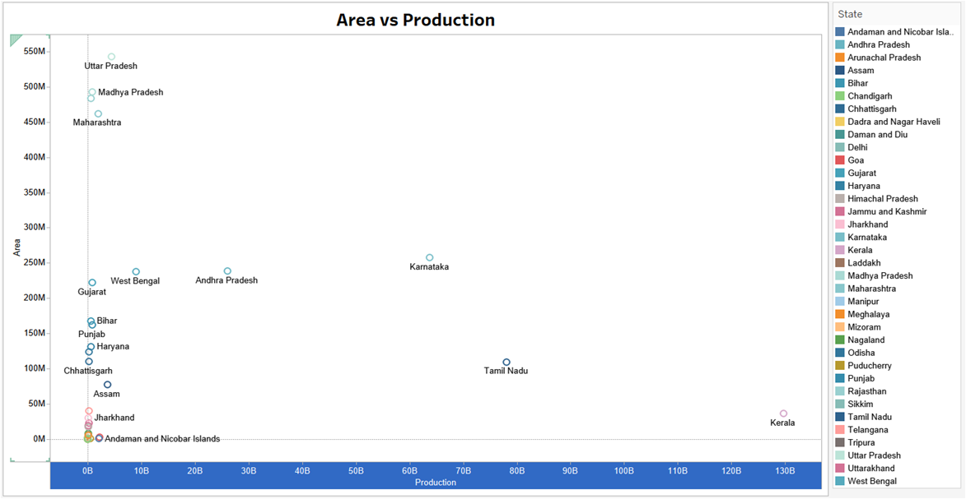

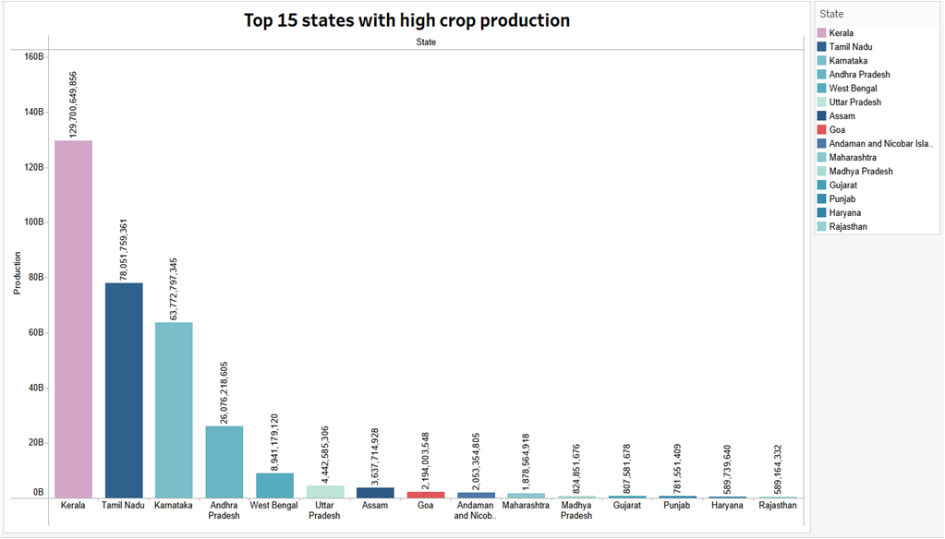
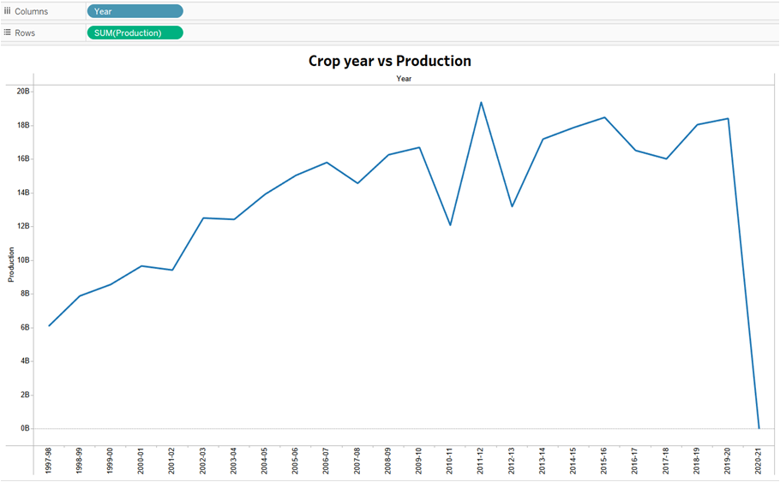

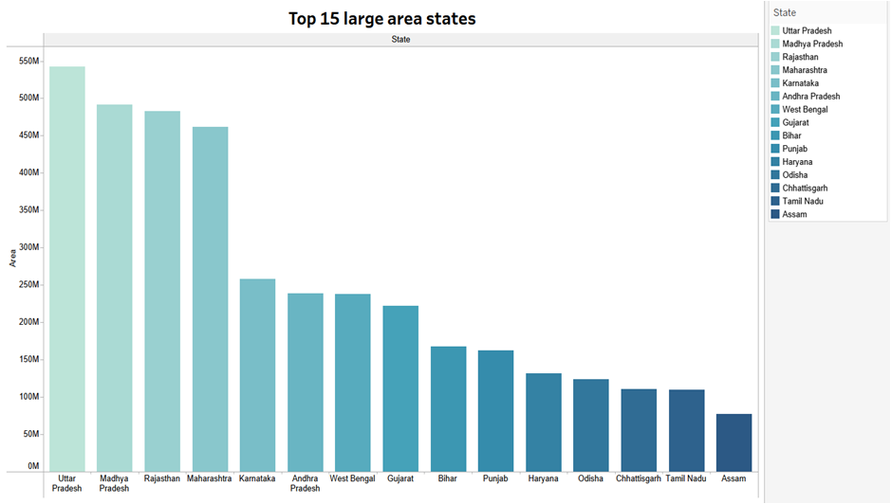

CONCLUSION

In conclusion, our project, "Indian Agriculture Crop Production Analysis in Tableau with Python Flask as Backend," offers a holistic solution for analyzing and visualizing crop production data. By harnessing the capabilities of Tableau for dynamic visualizations and Flask for efficient backend data processing, stakeholders are equipped with valuable insights into crop production trends, seasonal dynamics, and regional disparities.
This project empowers decision-makers in agriculture to optimize resource allocation, enhance sustainability initiatives, and drive informed policymaking for the benefit of the agricultural sector and the nation as a whole. By providing a user-friendly interface and actionable insights, our solution facilitates evidence-based decision-making and fosters positive change in Indian agriculture.
Through collaboration, innovation, and the integration of cutting-edge technologies, we pave the way for a more efficient, sustainable, and resilient agricultural sector, ensuring food security and prosperity for generations to come.

FUTURE SCOPE

Future scope refers to the potential avenues for further development, enhancement, and application of the system beyond its initial implementation. It involves identifying emerging trends, technologies, and opportunities that could shape the evolution of the system and its impact on stakeholders, organizations, and society. By anticipating future needs, challenges, and possibilities, stakeholders can proactively plan for ongoing innovation and adaptation to remain relevant and competitive in a dynamic and rapidly evolving environment.

One aspect of future scope involves exploring opportunities for scalability and extensibility to accommodate evolving requirements and user needs. This includes designing the system architecture and infrastructure in a modular and flexible manner, allowing for seamless integration of new features, functionalities, and data sources. By adopting standards-based interfaces, APIs, and protocols, organizations can facilitate interoperability, data exchange, and collaboration with external systems and services, thereby enhancing the system's value proposition and ecosystem.

Furthermore, future scope encompasses leveraging emerging technologies and trends to enhance the capabilities and performance of the system. This includes exploring advancements in areas such as artificial intelligence, machine learning, Internet of Things (IoT), blockchain, and cloud computing to unlock new possibilities for automation, predictive analytics, and real-time decision-making. By harnessing the power of data-driven insights and intelligent automation, organizations can optimize operations, improve efficiency, and drive innovation across various domains and industries.

Moreover, future scope involves addressing evolving user expectations and preferences to deliver a seamless and personalized user experience. This includes investing in user interface design, usability testing, and user feedback mechanisms to understand user needs, preferences, and pain points. By incorporating user-centric design principles, organizations can enhance user satisfaction, engagement, and loyalty, thereby driving adoption and usage of the system in the long term.

Additionally, future scope encompasses exploring opportunities for cross-domain integration and collaboration to address complex challenges and create synergies across different sectors and stakeholders. This includes forging strategic partnerships, alliances, and ecosystems to leverage complementary strengths, expertise, and resources. By fostering an open and collaborative innovation ecosystem, organizations can accelerate the pace of innovation, create new value propositions, and address societal challenges more effectively.

Furthermore, future scope involves anticipating and mitigating potential risks, uncertainties, and disruptions that could impact the system's performance, resilience, and sustainability. This includes conducting scenario planning, risk assessments, and contingency planning to identify and prioritize potential threats and vulnerabilities. By adopting a proactive and adaptive approach to risk management, organizations can enhance their resilience, agility, and ability to navigate unforeseen challenges and opportunities in an increasingly volatile and uncertain environment.

  - In summary, future scope encompasses a wide range of possibilities and opportunities for ongoing innovation, adaptation, and evolution of the system to meet changing needs, trends, and challenges. By embracing emerging technologies, addressing user needs, fostering collaboration, and managing risks, organizations can unlock new value propositions, drive sustainable growth, and maintain a competitive edge in today's dynamic and interconnected world.

REFERENCES

- Singh, R. B., & Kumar, A. (2018). "Assessment of Crop Production Trends
    - in India." International Journal of Agriculture, Environment and Biotechnology, 11(1), 93-100.
- Mishra, P., & Mohanty, B. (2020). "Impact of Monsoon Variability on Crop
    - Production: A Case Study of Indian Agriculture." Weather and Climate Extremes, 29, 100274.
- Kumar, S., & Rani, S. (2019). "Regional Disparities in Crop Production: A
    - Case Study of Indian States." Journal of Regional Development and Planning, 8(2), 67-84.
- Panwar, N., & Goyal, A. (2021). "Promoting Sustainable Agriculture in
    - India: Initiatives, Challenges, and Opportunities." Sustainable Development, 29(2), 365-382.
- Joshi, P. K., & Birthal, P. S. (2017). "Impact of Policy Interventions on
    - Agricultural Productivity and Rural Poverty in India." Agricultural Economics Research Review, 30(2), 183-196.

